https://www.pes.edu/wp-content/uploads/2019/09/pes_logo.png

**END SEMESTER ASSESSMENT (ESA) B.TECH. (CSE)**

**IV SEMESTER**

**UE18CS256 – MICROPROCESSOR AND COMPUTER ARCHITECTURE LABORATORY**

**PROJECT REPORT**

**ON**

**Lcd Count Display**

**SUBMITTED BY**

**NAME SRN**

1. **Veeresh Uppara PES2UG19CS450**
2. **Vishal P PES2UG19CS459**

**JANUARY – MAY 2021**

**DEPARTMENT OF COMPUTER SCIENCE & ENGINEERING**

**ELECTRONIC CITY CAMPUS,**

**BENGALURU – 560100, KARNATAKA, INDIA**

| TABLE OF CONTENTS | | |
| --- | --- | --- |
| Sl.No | TOPIC | PAGE No |
|  | ABSTRACT OF THE PROJECT |  |
|  | CIRCUIT DIAGRAM |  |
|  | ARDUINO CODE |  |
|  | SCREENSHOTS OF THE OUTPUT |  |
|  | REFERENCES |  |

**ABSTRACT OF THE PROJECT:**

We have designed and implemented a simple increment-decrement counter and a LCD display.

Keeping in mind the present situation we are living in, it is really important to maintain social distancing and this can be achieved by the device we have implemented.This device is helpful in keeping a count of students in school or classroom and it helps us in maintaining the prescribed percentage of students in a class thereby ensuring all social distancing is followed.

Our device has a buzzer which would sound an alarm when the capacity of students is more than the prescribed or permissible limit.

Students would be required to click on the button to allow them to be counted while entering the classroom.While they move out of the room they would be required to click on the decrement count button which makes sure that other students would be able to use the classroom or any facility on the campus.

A few applications of our device would be:

* Student count in classroom
* Employee count in company
* In busses to maintain the permissible limit
* In malls and shopping centres
* And also to count number of vaccinations at centres

**CIRCUIT DIAGRAM:**

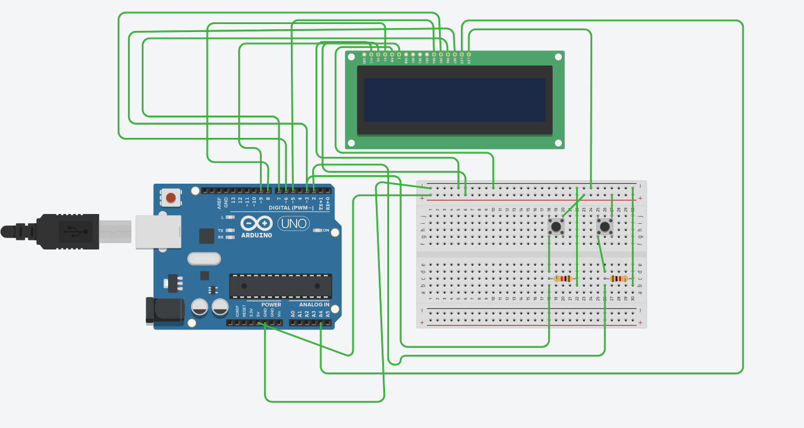

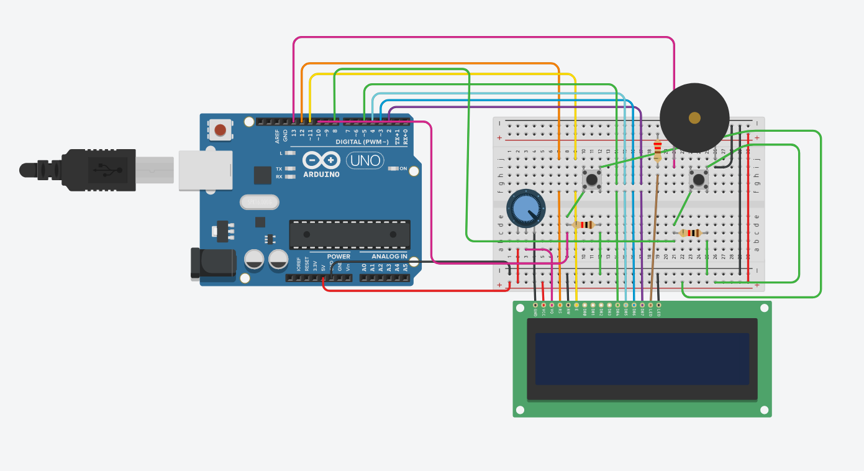

**ARDUINO CODE:**

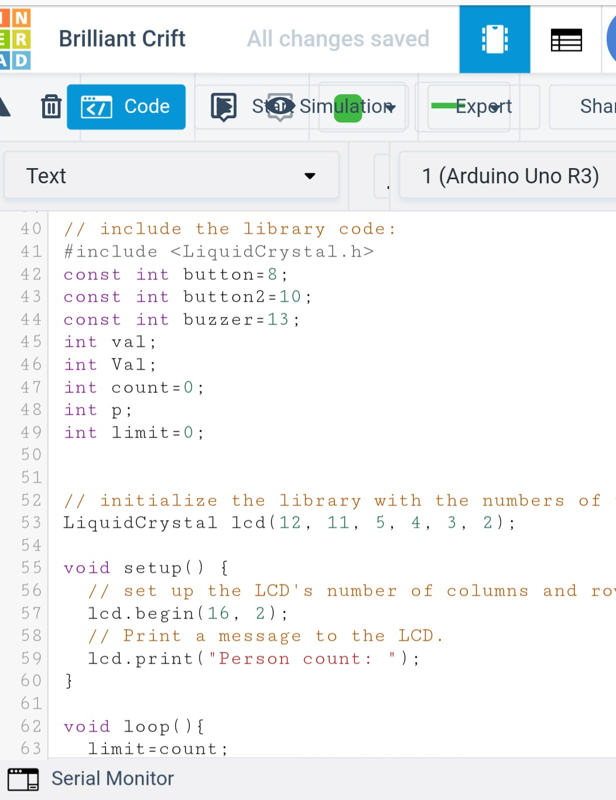

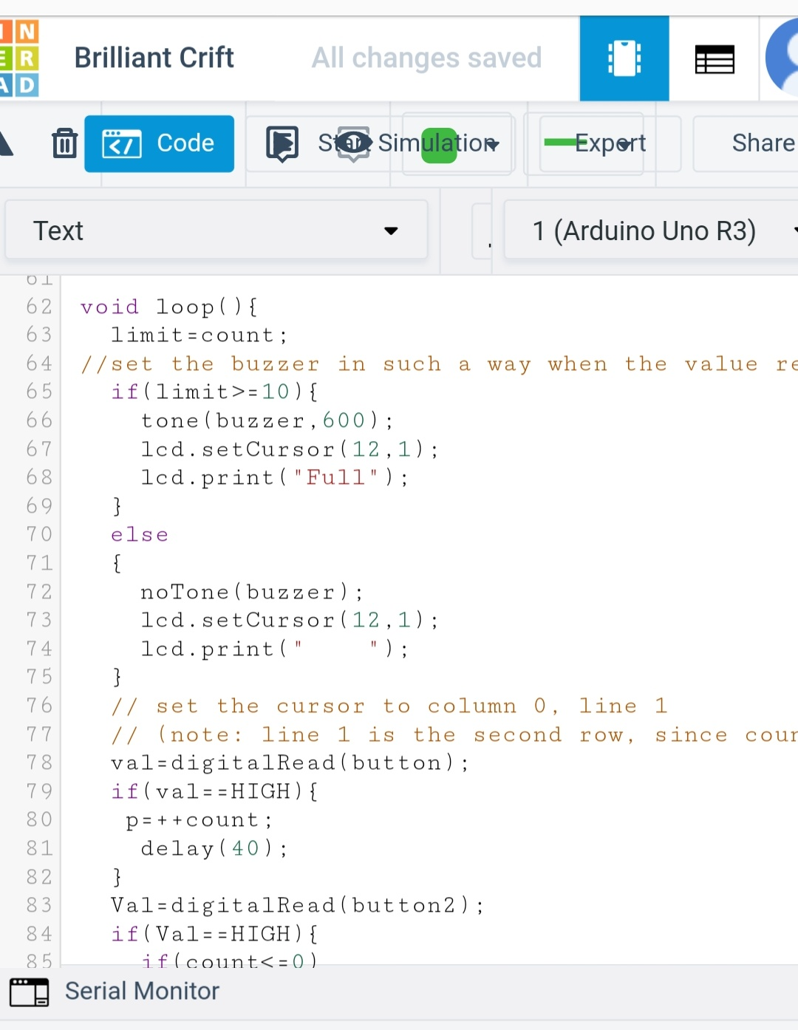

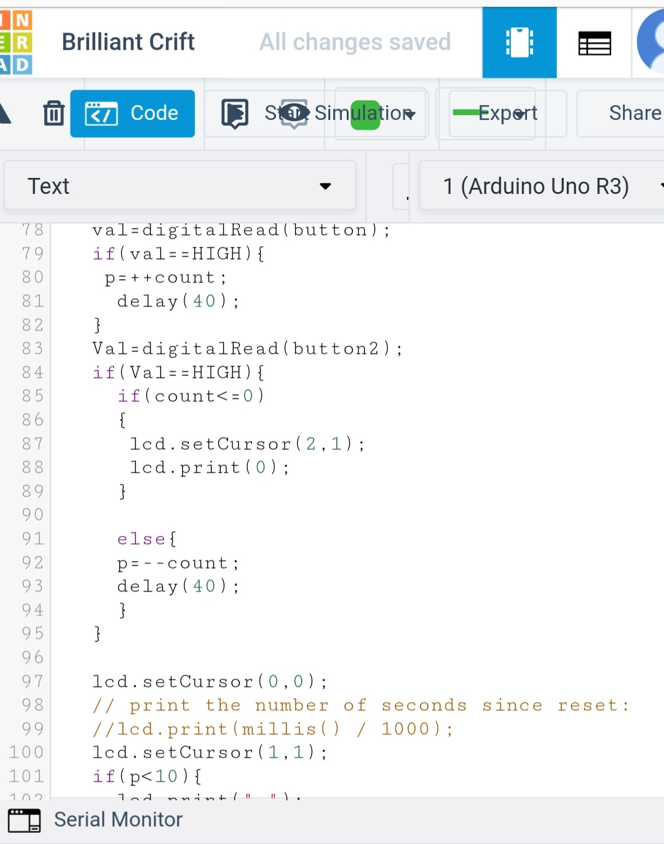

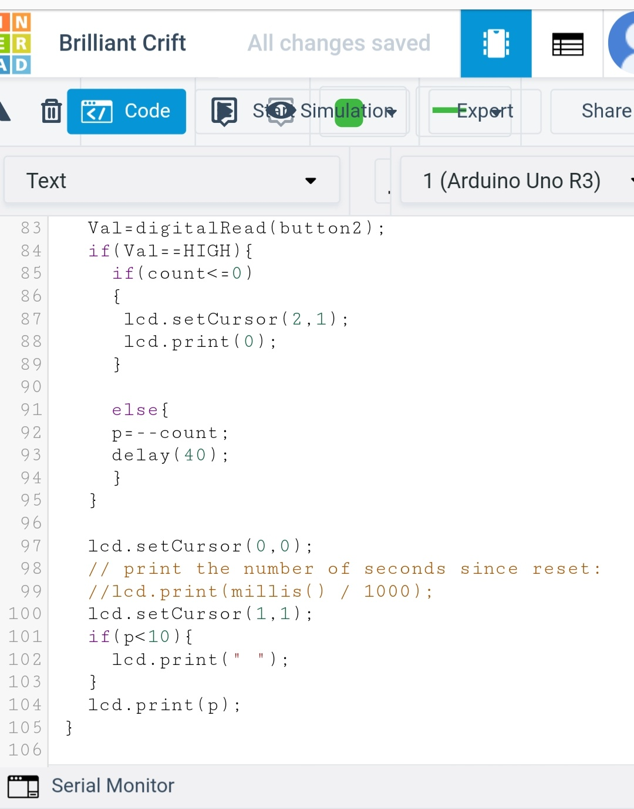

**SCREENSHOTS OF THE OUTPUT:**

**Start State:**

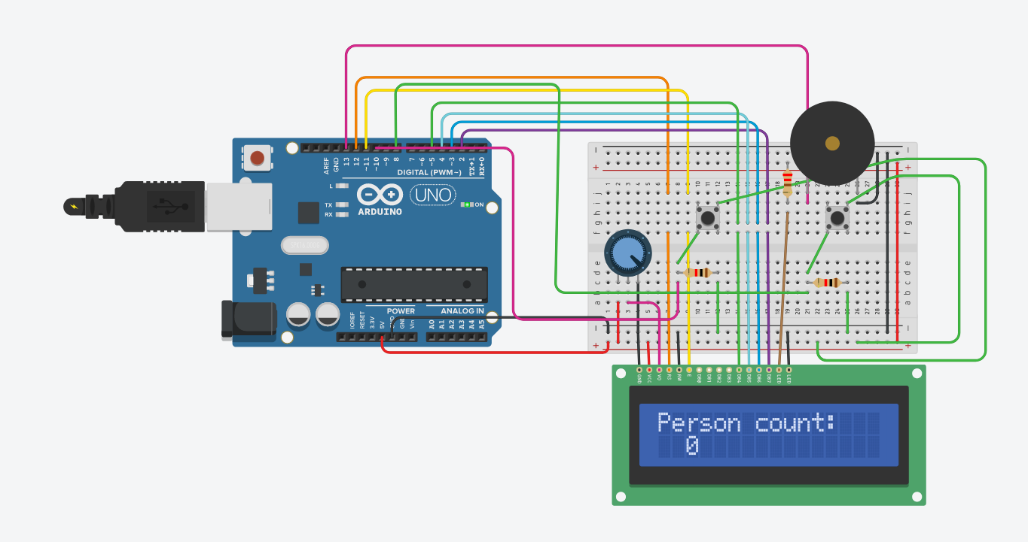

**Increment of person count:**

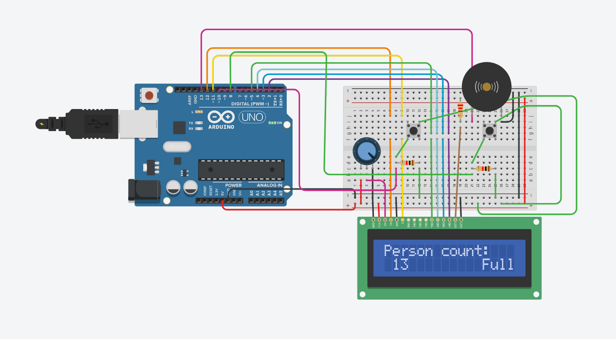

**Decrement of person count:**

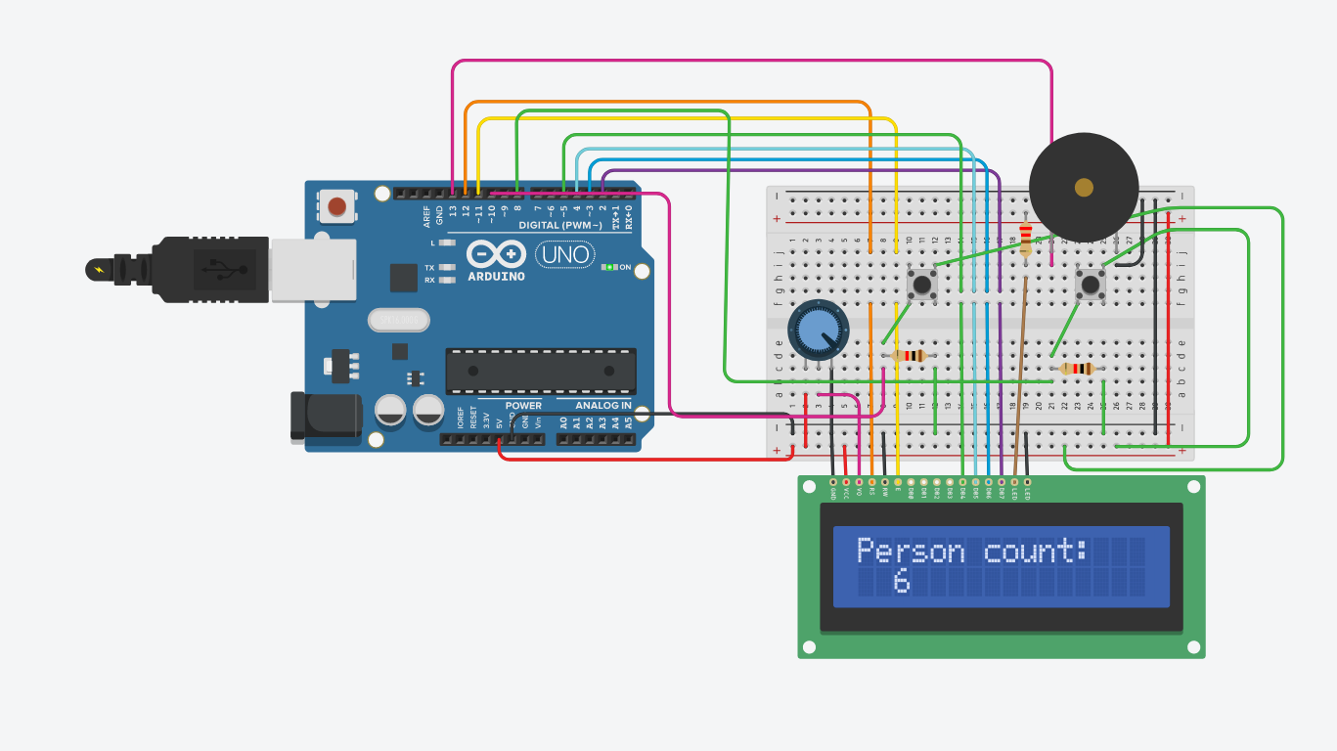

**REFERENCES**